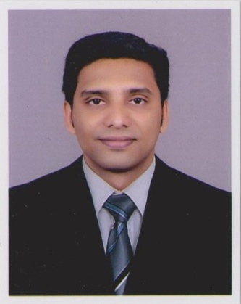
Sreejith Sreekumar

Contact Information

Permanent Address: ‘Harisree’, TC 42/318[4]
Parambil Nagar, Vallakadavu PO
Thiruvananthapuram, Kerala, India
Zip – 695008
Mobile: +91 9961053423
Res: +91 471 2451807
Email: sreeji_nair@hotmail.com
Skype Id jith.kmr

Personal Particulars

Date of Birth: 01/11/1985
Gender: Male
Marital Status: Married
Nationality: Indian
Passport No: H4167098

Career Objective

Aiming to be associated with a Progressive Organization that gives the scope to update my knowledge and skills in accordance with the latest trends and to be a part of the team that dynamically works towards the growth of the organization and gain satisfaction thereof.

Profile

- Dynamic 7.5 year career in travel industry reflecting pioneering experience and outstanding ability to organize manage & coordinate travel details for both individual and corporate clients.
- Expert in dealing with Guests and providing prompt & excellent services.
- Designing and developing Tour Itineraries & Tour Coordination.
- Building & maintaining rapport with key suppliers to ensure prompt and quality service.
- Exceptionally well organized with a track record that demonstrates self motivation, leadership and initiative to achieve both personal and organizational goals.

Education

- Diploma in Airport Handling, (KITTS), Trivandrum : 2007
- Diploma in Computerized Financial Accounting (DCFA), LBS, TVM : 2006
- B.Com degree from University of Kerala. : 2003 - 2006
- Plus-2 from Board of Higher Secondary Examination Kerala. : 2001 - 2003
- SSLC from Board of public examinations Kerala. : 2001

Professional Experience

- Dream Journeys Travel Hub Pvt. Ltd May 2012 – Present
Designation: Asst: Manager – Leisure

- Great India Tour Company Jan 2010 – April 2012
Designation: Senior Executive – Tours

- The Travel Planners Feb 2009 – Dec 2009
Designation: Executive – Operations/Guest Relation

- Cocohol Tours & Travels Dec 2007 – Jan 2009
Designation: Executive Trainee – Tours/Operations

Skills

- Languages [Written & Spoken]
English. Malayalam. Hindi.

- Computer Knowledge
Proficient in MS Office
Tally

Reference

- Mr. Abhilash V Nair, Director, Dream Journeys Travel Hub Pvt. Ltd, Trivandrum
- Mr. V. Rajeevan, Director, KITTS, Trivandrum.
Declaration:

I, Sreejith.S do hereby confirm that the information given above is true to the best of my knowledge.

Place: Trivandrum
Date: 17/Aug/2015 Sreejith.S

